PRACTICE-WORK-1

Name: MANOJ KUMAR NATHA

NETID: mxn151930

1. Drop the foreign key constraint on ssn on WORKS_ON table (FKWONEM) and redefine it by adding "cascade delete" action.

ALTER TABLE WORKS_ON

DROP CONSTRAINT FKWONEM CASCADE;

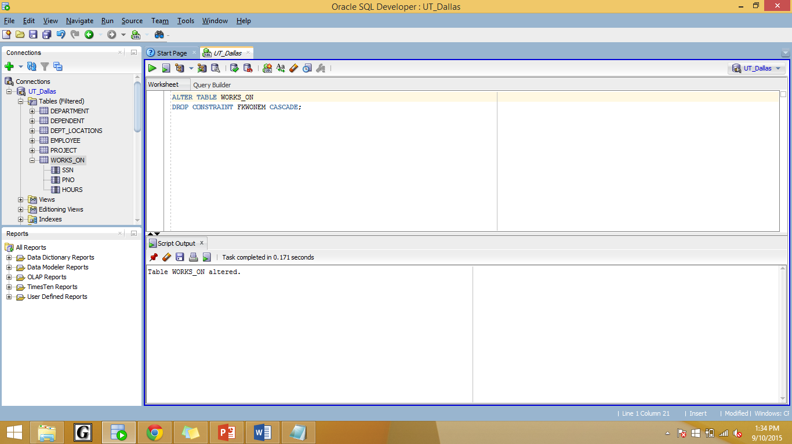

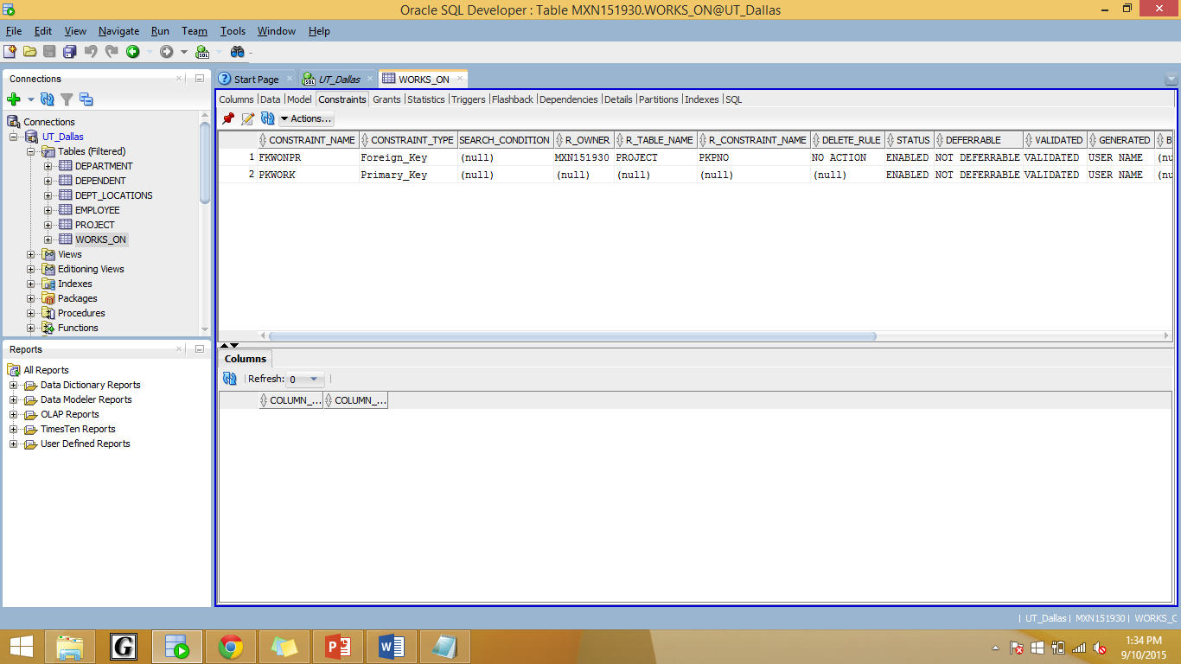

ALTER TABLE WORKS_ON

ADD CONSTRAINT FKWONEM

FOREIGN KEY (SSN) REFERENCES EMPLOYEE(SSN)

ON DELETE CASCADE;

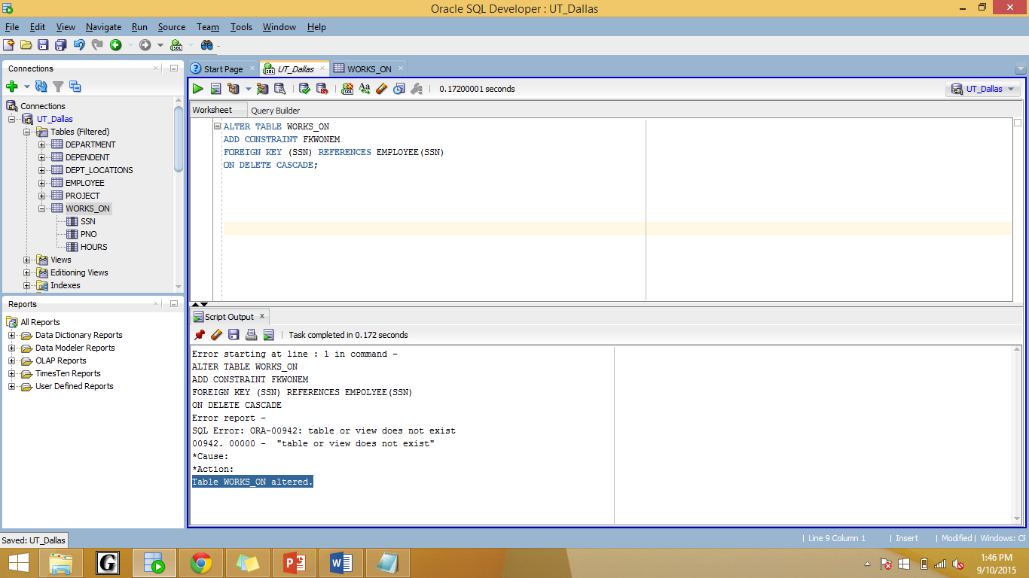

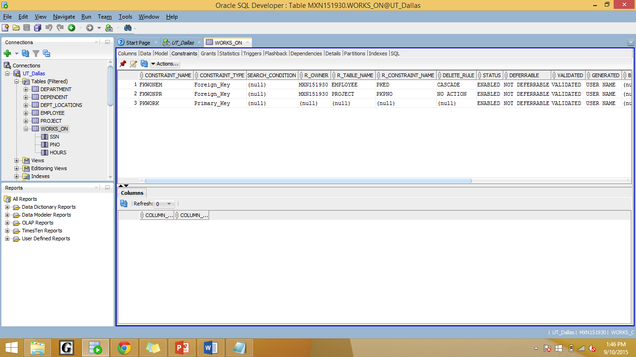

2. Drop the foreign key constraint on ssn on DEPENDENT table (FKDEPEFK) and redefine it by adding "cascade delete" action.

ALTER TABLE DEPENDENT

DROP CONSTRAINT FKDEPEFK CASCADE;

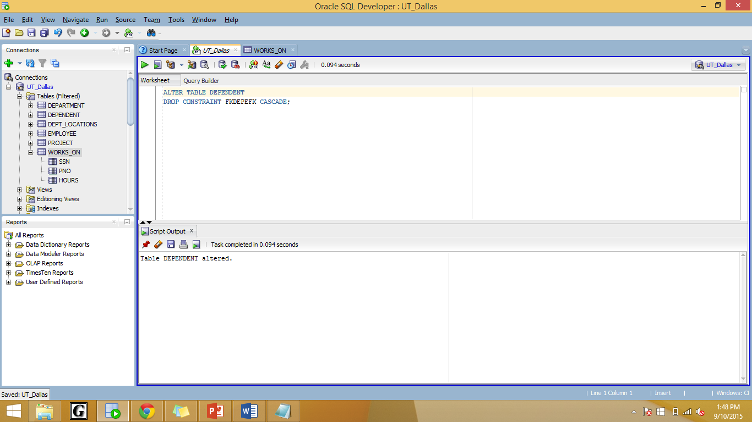

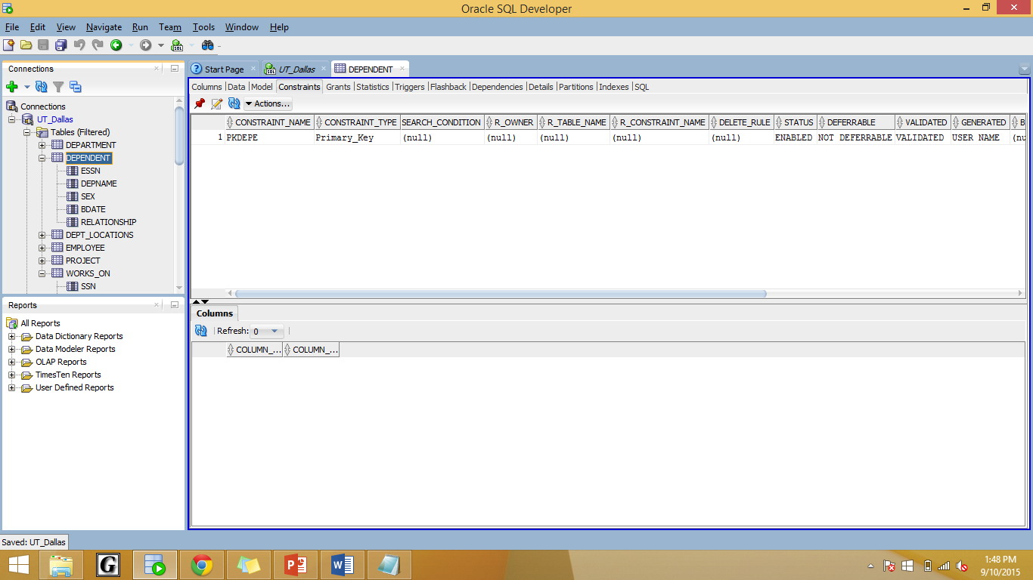

ALTER TABLE DEPENDENT

ADD CONSTRAINT FKDEPEFK

FOREIGN KEY (ESSN) REFERENCES EMPLOYEE(SSN)

ON DELETE CASCADE;

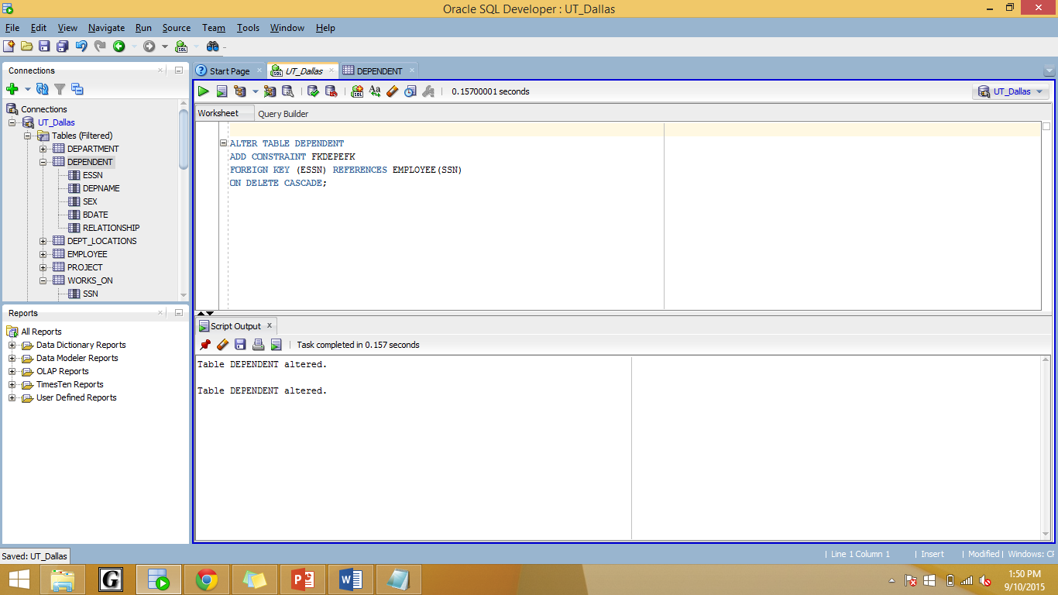

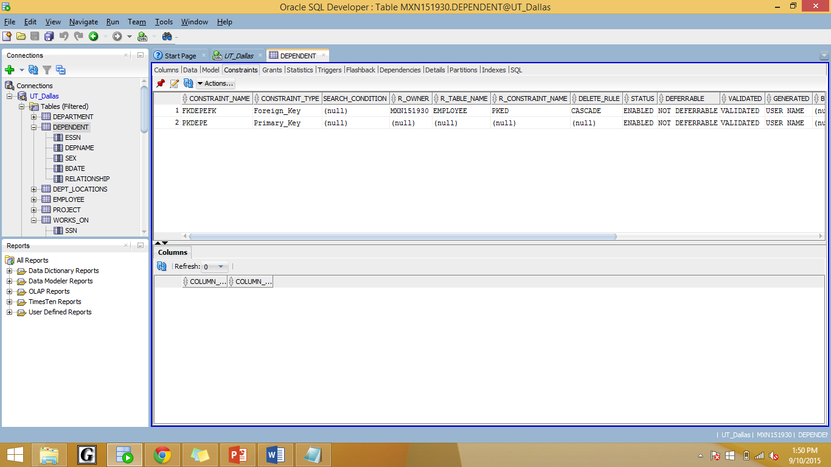

3(new). Find all employees that don’t have a supervisor.

SELECT *

FROM EMPLOYEE

WHERE SUPERSSN IS NULL;

3(old).Delete all employees that don’t have a supervisor.

DELETE FROM EMPLOYEE

WHERE SUPERSSN IS NULL;

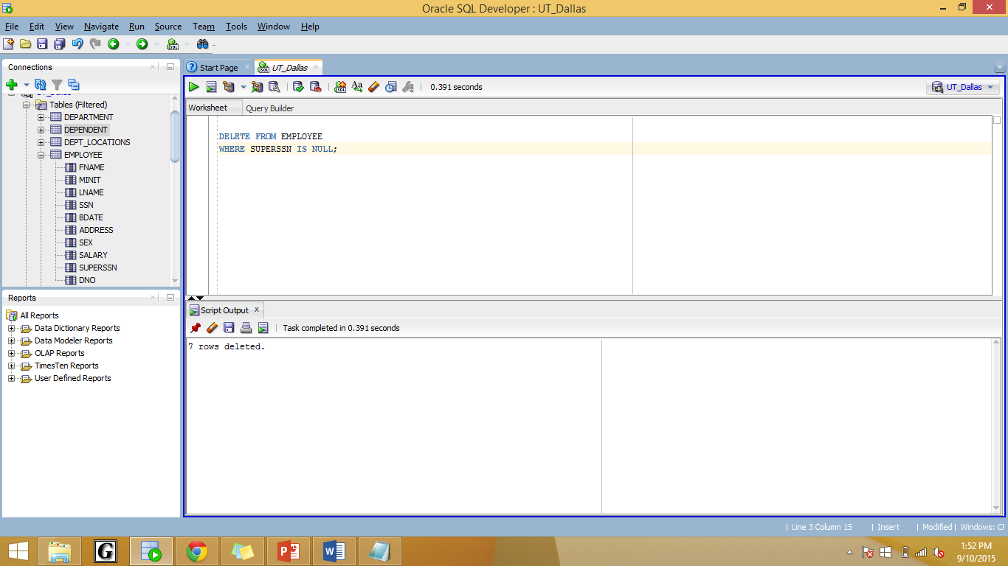

4. Add a new foreign key constraint to EMPLOYEE table on SuperSsn.

ALTER TABLE EMPLOYEE

ADD CONSTRAINT FKSUPSSN

FOREIGN KEY (SUPERSSN) REFERENCES EMPLOYEE(SSN);

5. List the names of employees in department 6 with no dependents.

SELECT Fname, Lname

FROM EMPLOYEE

WHERE Dno=6 AND NOT EXISTS (SELECT *

FROM DEPENDENT

WHERE Ssn =Essn);

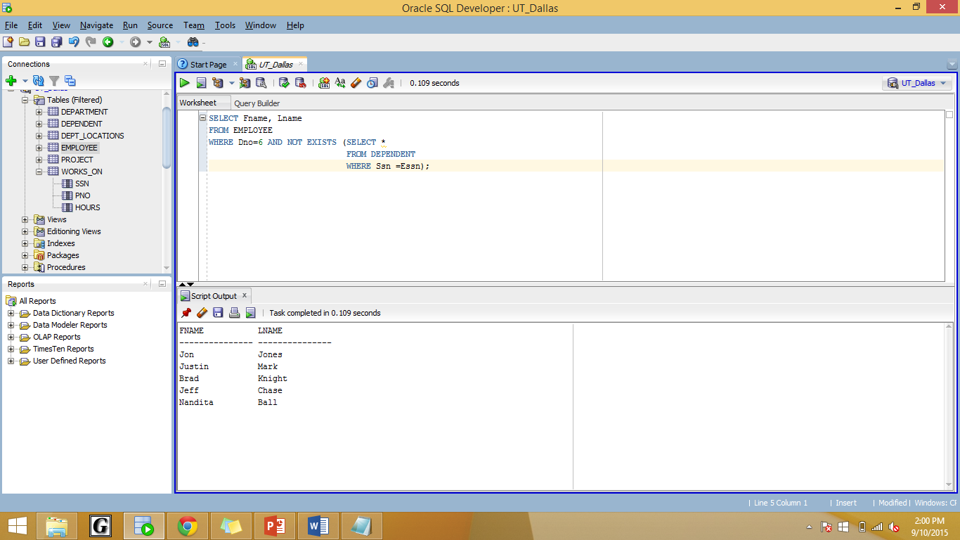

6. List the names of employees earning more than their supervisors.

SELECT E1.Fname, E1.Lname

FROM EMPLOYEE E1

WHERE E1.Salary > ( SELECT E2.Salary

FROM EMPLOYEE E2

WHERE E2.Ssn=E1.Superssn);

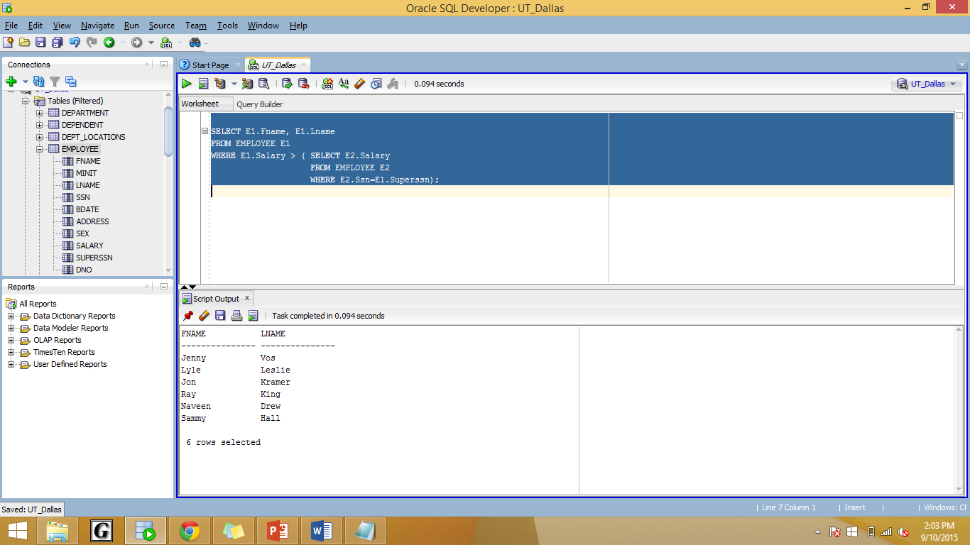

7. List the employees who earn maximum salaries in their departments and the salary they earn. (20 points)

SELECT E1.Fname, E1.LNAME, E1.DNO, E1.Salary

FROM EMPLOYEE E1

WHERE (E1.Salary,E1.DNO) IN (SELECT MAX(E2.Salary), E2.DNO

FROM EMPLOYEE E2

GROUP BY E2.DNO);

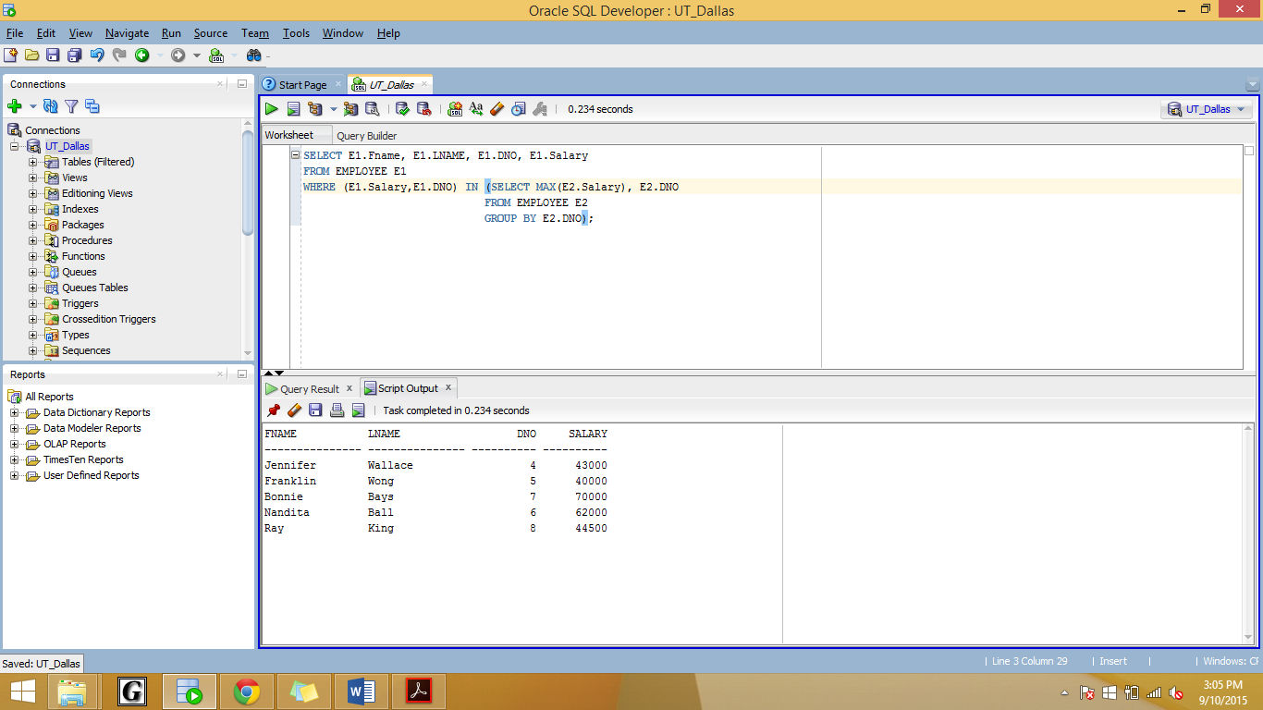

**// BEST SOLUTION:**

**SELECT \***

**FROM EMPLOYEE E1**

**WHERE E1.Salary = ( SELECT MAX(E2.Salary)**

**FROM EMPLOYEE E2**

**WHERE E1.Dno=E2.Dno);**

8. Find the number of employees and their average salary in each department that has at least 5 employees earning more than $40000. (20 points)

SELECT Dno, COUNT(*), AVG(SALARY)

FROM EMPLOYEE

WHERE Salary>40000

GROUP BY Dno

HAVING COUNT(*) >= 5;

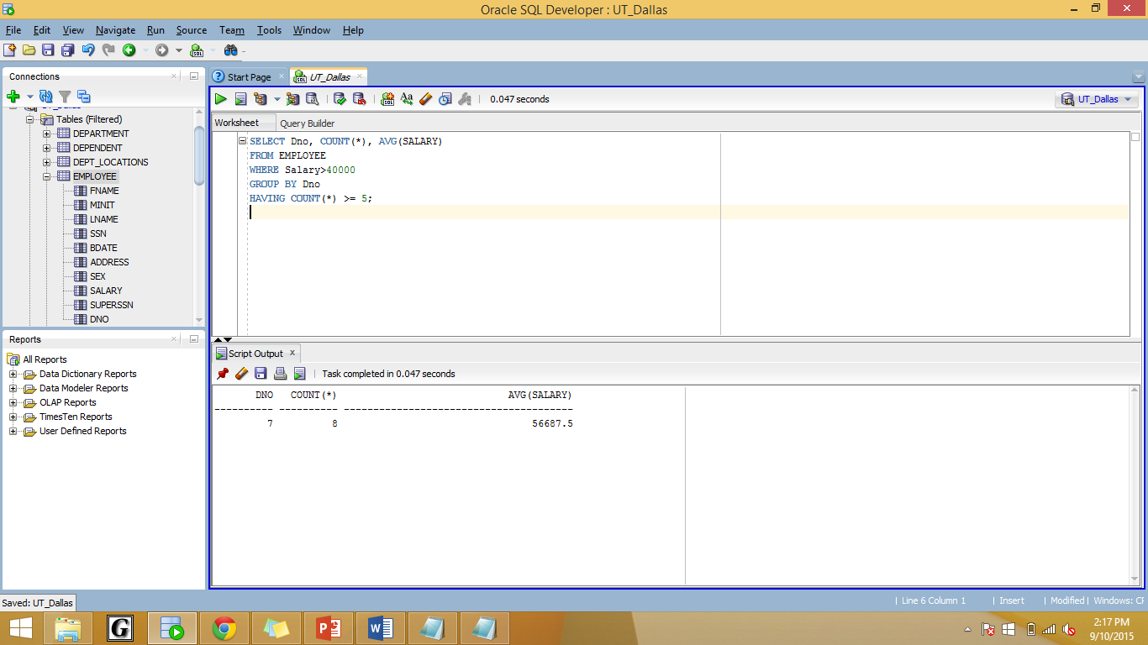

**// CORRECT SOLUTION:**

**SELECT Dno, COUNT(*), AVG(SALARY)**

**FROM EMPLOYEE E1**

**WHERE E1.Dno IN (SELECT E2.Dno**

**FROM EMPLOYEE E2**

**WHERE E2.Salary>40000**

**GROUP BY E2.Dno**

**HAVING COUNT(*) >= 5)**

**GROUP BY Dno;**

**SELECT FName, LName**

**FROM EMPLOYEE**

**WHERE NOT EXISTS(**

**(SELECT Pno FROM PROJECT WHERE Dno=5)**

**MINUS**

**(SELECT DISTINCT Pno FROM WORKS_ON**

**WHERE Essn=ssn))**